ImageJ Instructions for VPR users

Emily O’Grady May 2022 | Bedford Institute of Oceanography

# Introduction

These instructions lay out the procedure for running VPR (Video Plankton Recorder) images through ImageJ as a processing method to extract measurement information about each of the images. This procedure is meant to replace the existing measurement output currently calculated through Visual Plankton (VP) in MatLab. The workflow was developed for use with DAVPR-14 but would be generally applicable to dark-field plankton images.

ImageJ is an open-source image processing software designed for science. It allows the programming of ‘macros’ which allows batch processing of many images. The tools available allow a user to manipulate and measure images. The goal of this workflow is to output a table of measurements (major and minor length) which represent the dimensions of objects within ROI (Region of Interest) images. This workflow was designed to work with output from AutoDeck (SeaScan’s image segmentation tool designed for VPR), but could be generalized to work with other images.

# Set-Up

1. Download ImageJ: <https://imagej.nih.gov/ij/download.html>
2. Download macro script, place this script in your ImageJ/macros folder



1. Set-up VPR measurement macro
   1. Open ImageJ (double click ImageJ.exe)
   2. Navigate the top menu ‘Plugins’ > ‘Macros’ > ‘Install’
   3. When you navigate the top menu ‘Plugins’ > ‘Macros’ You should now see an option at the bottom ‘measure_roi’
2. Choose the measurements you wish to output
   1. Navigate the top menu bar ‘Analyze’ > ‘Set Measurements..’
   2. 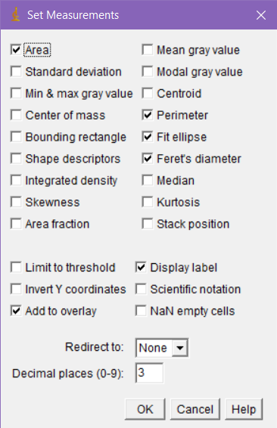
   3. These can be adjusted based on user preference, see above for the settings used in this example. Your selection will persist between ImageJ sessions.

# Workflow (Single Image)

1. Once images have been processed and a user wishes to extract measurements (this could be after autodeck processing or after complete classification?)
2. Open ImageJ.exe
3. Navigate the top menu bar ‘File’ > ‘Open’ and select a ROI image.

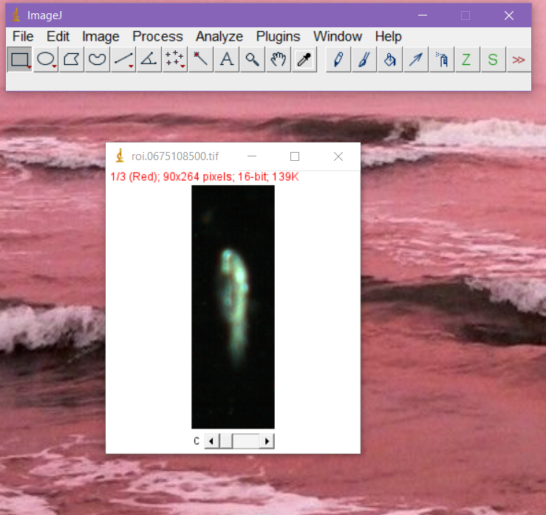

1. Navigate the top menu bar, ‘Plugins’ > ‘Macros’> ‘measure_roi’
2. Three windows will open, as below (Note: They may be overlapping, rearrange them for an ideal view)

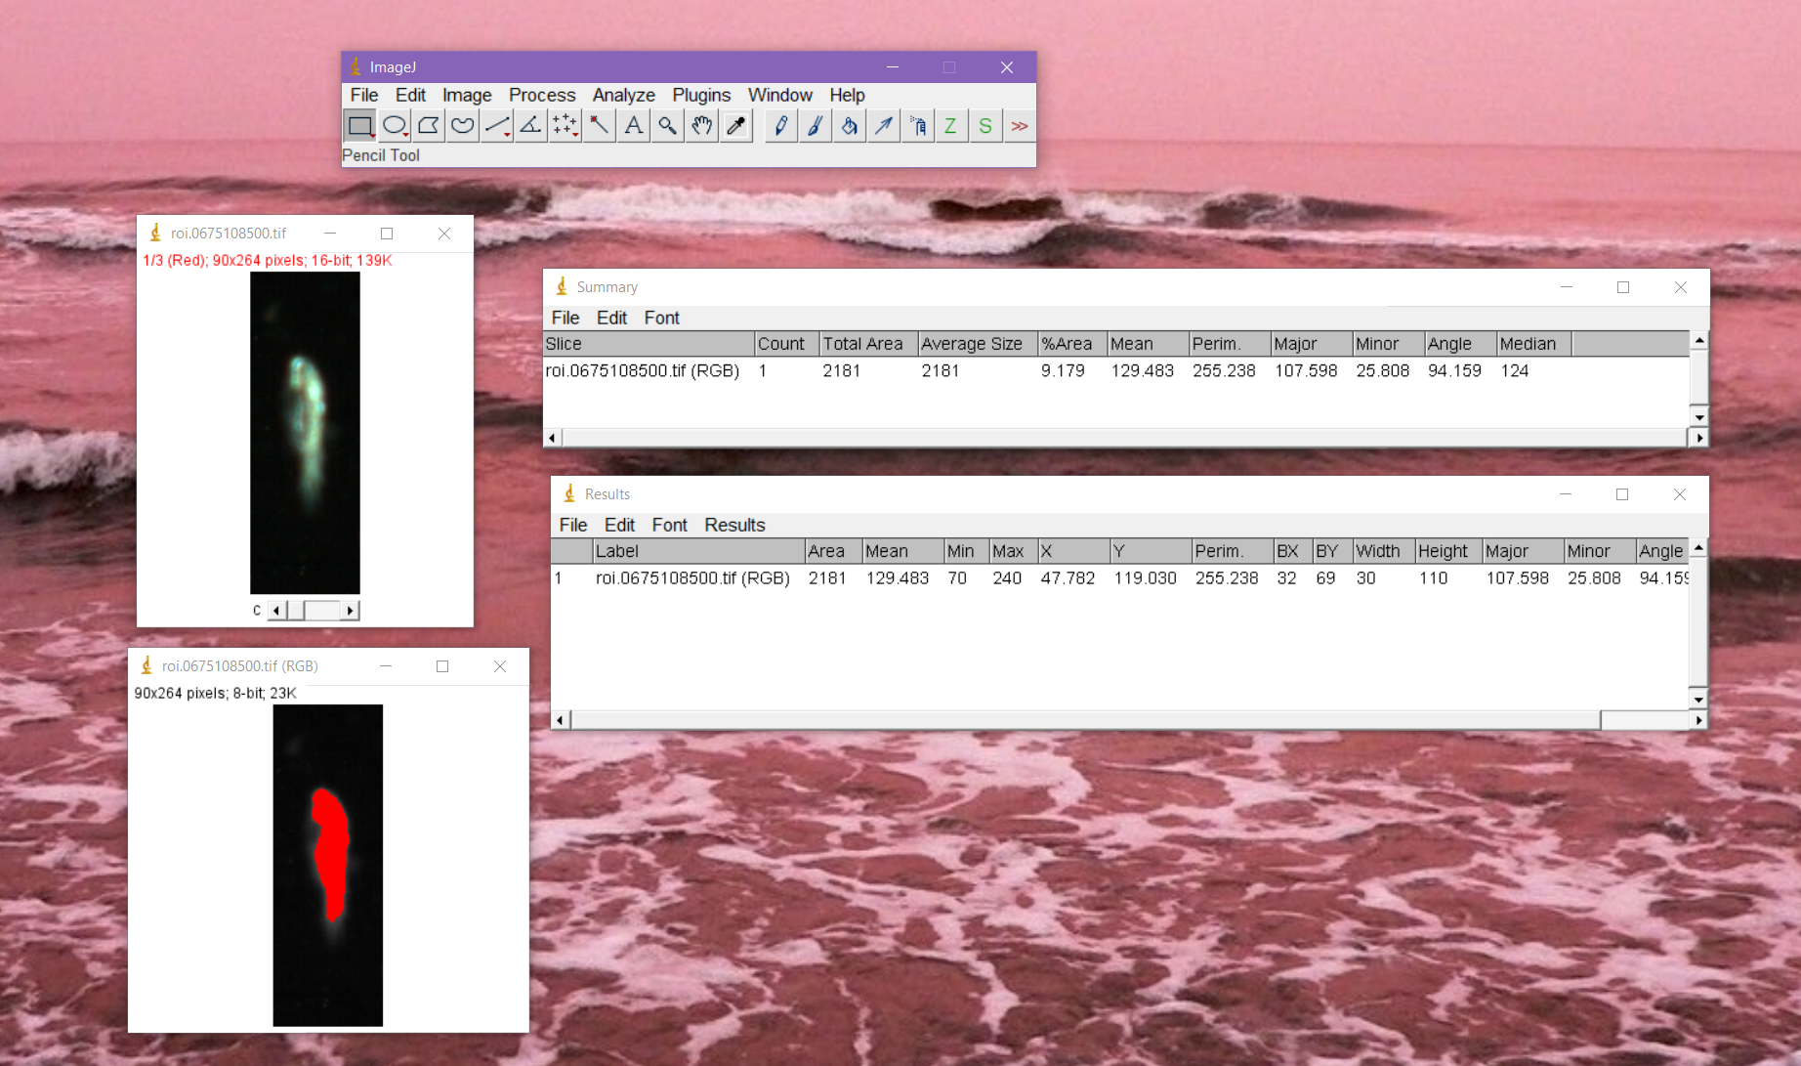

Your measurements will be displayed in both the summary and results windows (RHS of the screenshot above).

On the LHS, you can see your original image (RGB, above), and the threshold, high contract image (below) which was used for measurement. You can see in the example that this may not always be a perfect representation of the actual object in the image.

1. Save your measurements
   1. First ensure that column headers will be saved with your data, navigate the top menu of the ‘Results’ window, ‘Results’ > ‘Options’, and select ‘Save column headers’. This only needs to be done once per session.
   2. Navigate the top menu (of the Results window again) ‘File’ > ‘Save as…’
   3. Select a location to save your measurement data
2. Measurement data may need additional manipulation in Excel, or your programming language of choice.

Note that attempting to open measurement data in R resulted in an error. I had to open the data in excel first to convert the file to csv, this will have to be adjusted before this workflow is fully implemented.

# Workflow (Batch)

1. Once images have been processed and a user wishes to extract measurements (this could be after autodeck processing or after complete classification?)
2. Open ImageJ.exe
3. Navigate the top menu, ‘Process’ > ‘Batch’ > ‘Macro’
4. Use the ‘Open’ button at the bottom of the batch process window to open the desired macro
5. Select your ‘Input’ directory of the images you wish to measure. Your batch process pop-up window should look as below.

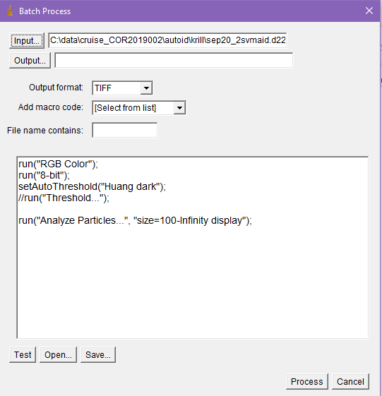

1. Click ‘Process’ to begin the measurement process
2. ImageJ will open two windows, and begin measuring the images. Once the windows stop loading data, the images are finished (typically pretty fast, less than 1 minute)
3. In the ‘Results’ window, navigate the top menu bar ‘Results’ > ‘Options’. Check ‘Save column headers’, and click ‘Okay’. This ensures that when you save your data the column headers will also be saved.

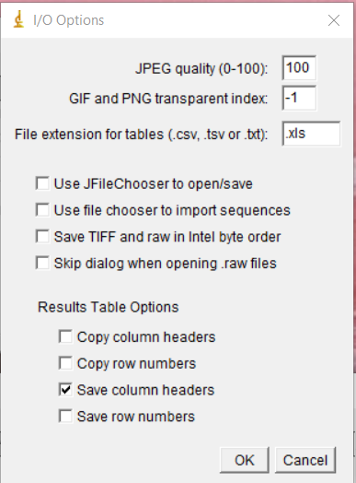

1. Navigate the top menu, ‘File’ > ‘Save as’, and save your results file. The suggested location for this file would be in the directory above the folder where the images are located. Eg. If your images are in c:/data/…/d000/h00, put your measurement summary in c:/data/…/d000 and name it based on the hour processed.
2. Your results will be in .xls format and look something like the sample below.



This data will need further manipulation in your preferred programming language, or it could be done directly in excel. It should be saved as a csv for smoothest processing in R.

# Workflow (FIJI)

This workflow is slightly modified but easier to run large batches and more clearly reproducible.

It requires a newer version of ImageJ (FIJI). It has advantages in that it includes all the appropriate settings and is therefore more portable and easier to share with other users. It would also be easier to build on if we decide to do other processing in ImageJ.

1. Setup
   * + Install FIJI from <https://imagej.net/software/fiji/downloads>
2. Open the app (ImageJ-win64.exe inside the FIJI folder)
3. Navigate the top menu – ‘File’ > ‘Open…’ and select the file below (you should save it somewhere locally)



This will open the script in a text editor. It should look like this:

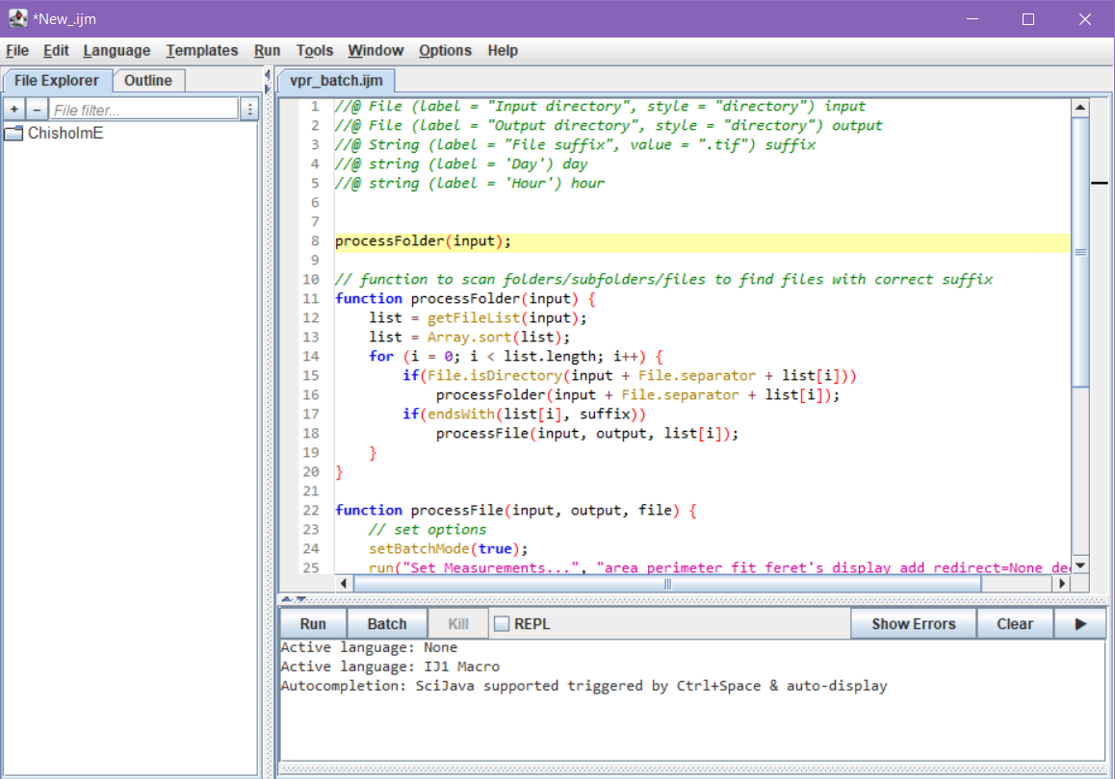

*If the code is not properly colourized, you may need to tell the editor which language the code is in. Do this by navigating the top menu ‘Language’ > ‘IJ1 Macro’.*

1. Run the script, by clicking ‘Run’ (left most button in between top and bottom pane)
2. This will bring up a widget prompt, enter the following:
   1. An Input Directory (where are the images you would like to process)
   2. An output directory (where your results will be saved as a csv)
   3. The file suffix of images you are processing (‘.tif’)
   4. Day and hour you are processing (to properly name the results file)

# Notes

These are some things learned through trial and error, processing different images

* + - The choice of threshold method is very important to the results (*see Threshold Analysis section below*)
    - When updating the threshold method in the macro text, make sure you keep the ‘dark’ parameter as this can also have dramatic effects on results
    - Setting a minimum size of 100 pixels for ellipses to be analyzed helps reduce some of the noise from marine snow particles which were skewing the summary averages
    - Feret Diameter is a helpful measurement which captures maximum length of a ROI but is more susceptible to influence by ‘pointy bits’, eg. extended antennae of a copepod. Best fit ellipse is still the best choice for measuring copepods.
    - It is important to save the results and not the Summary measurements to avoid errors due to averaging of multiple objects within a ROI image

# Comparison with VP

An initial comparison between ImageJ and Visual Plankton measurements.

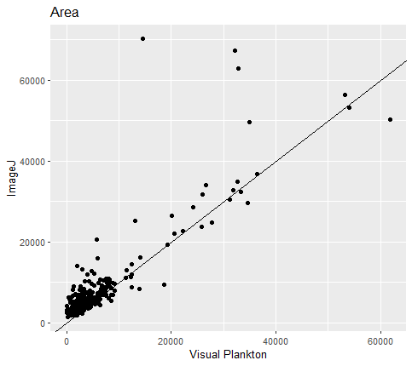

Area agrees well between measurement methods.

Figure Area of objects within ROI images as measured by Visual Plankton and ImageJ , in pixels. ImageJ results reflect the (area of) largest detected best fit ellipse in a particular image.

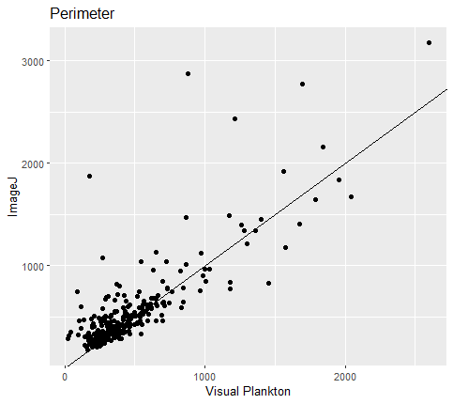

Perimeter agrees well

Figure Perimeter of objects in ROI images as measured by Visual Plankton and ImageJ, in pixels. ImageJ results reflect the (perimeter of) largest detected best fit ellipse in a particular image.

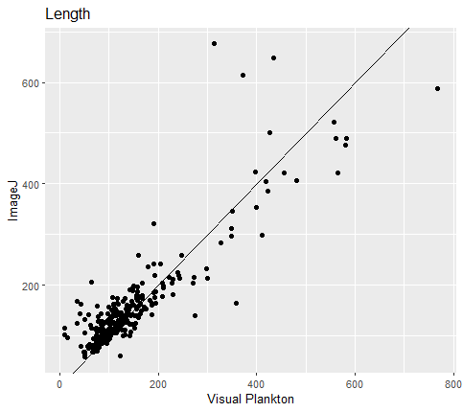

In ImageJ this corresponds to the ‘Major’ measurement which represents the longer axis of a fitting ellipsoid. In VP this measurement is ‘long_axis_length’ which is under suspicion according to other VP users. They seem to agree well.

Figure Width measurements of ROI objects as measured by Visual Plankton, and ImageJ, in pixels. Colour represents the number of best fit ellipses measured in an image (blue is more than one ellipse, red is one ellipse) . ImageJ results reflect the (lengthr of) largest detected best fit ellipse in a particular image.

Overall, the important points of the ImageJ and VP comparison:

* + - Measurements where methods for both platforms are clear are in good agreement
    - ImageJ measurement methods are more transparent and easier to manipulate, adjust and export
    - ImageJ allows simple batch processing and is easily incorporated into the existing R workflow
    - ImageJ is better documented than VP for troubleshooting and modifications
    - Some degree of variance is to be expected due to automated techniques

# Read ImageJ data into R

library(tidyverse)

# load in results file

resdat <- read.csv('c:/data/cruise_cor2019002/autoid/krill/d222h03_meas_results.csv')

# fix column names

resdat <- resdat %>%

rename(., roi = "ï..Label")

# isolate roi number

resdat$roi <- as.character(readr::parse_number(x = resdat$roi, trim_ws = TRUE, locale = locale(grouping_mark = '.')))

# pull only largest meas from each ROI (is this final method? may be cases where summing would be better?)

resdat_m <- resdat %>%

group_by(roi) %>%

filter(Area == max(Area))

# Resources

<https://imagej.nih.gov/ij/docs/install/windows.html>

<https://imagej.nih.gov/ij/developer/macro/macros.html#:~:text=To%20try%20one%2C%20open%20it,folder%2C%20inside%20the%20ImageJ%20folder>.

<https://imagej.nih.gov/ij/docs/menus/analyze.html>

<https://imagej.nih.gov/ij/docs/macro_reference_guide.pdf>

<https://imagej.nih.gov/ij/docs/guide/146-28.html>

<https://imagej.nih.gov/ij/docs/guide/146-22.html>

# Appendix I: Macro Description

Measure_roi macro:

1. run("RGB Color");
2. run("8-bit");
3. setAutoThreshold("Default dark");
4. //run("Threshold...");
5. run("Analyze Particles...", "display clear summarize");

Description of macro function:

Line 1 adjusts the type of image, combining all three colour channels to allow for further processing

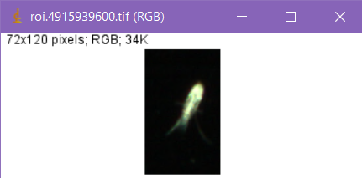

Line 2 converts the image to grayscale

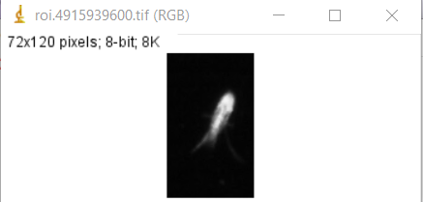

Line 3 & 4 ‘thresholds’ the image

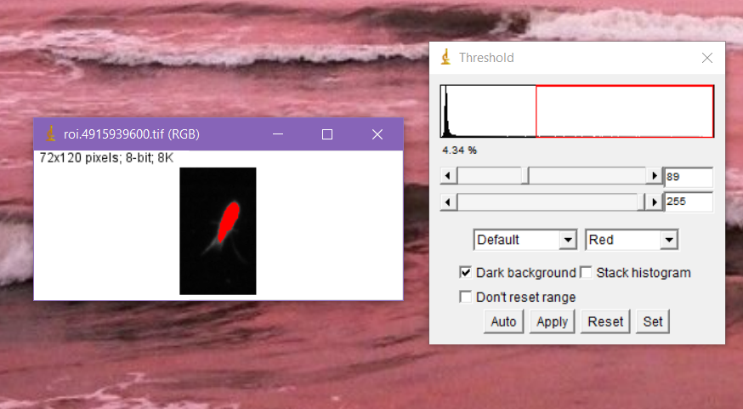

Line 5 Measures the threshold image, producing the measurements selected in set-up

# Threshold Comparison

## Default

# 

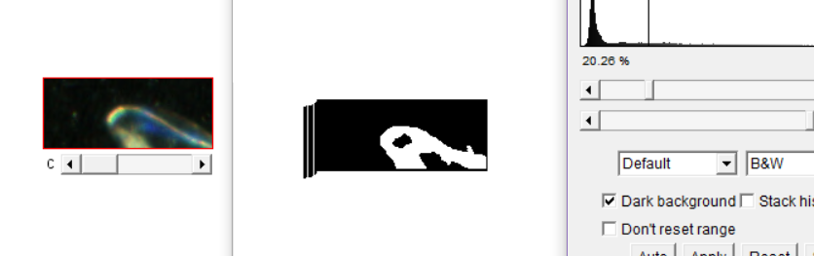

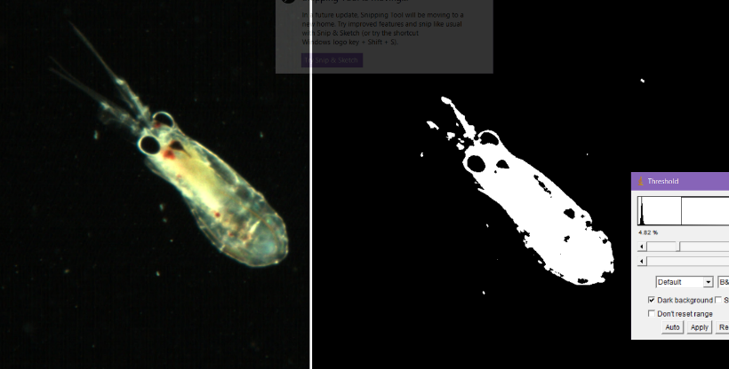

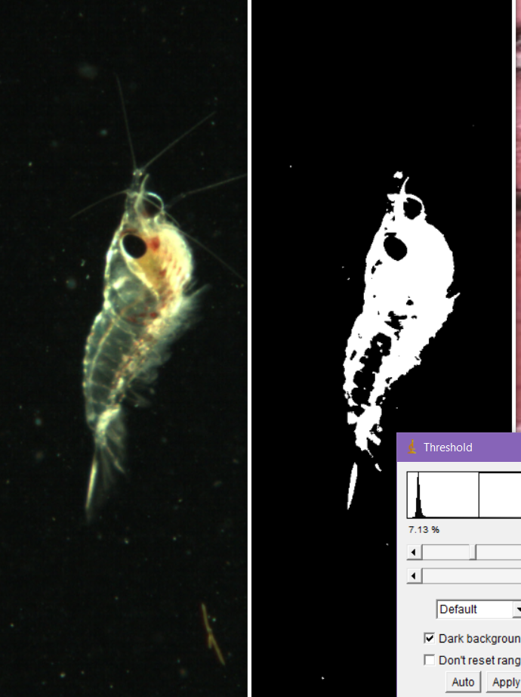

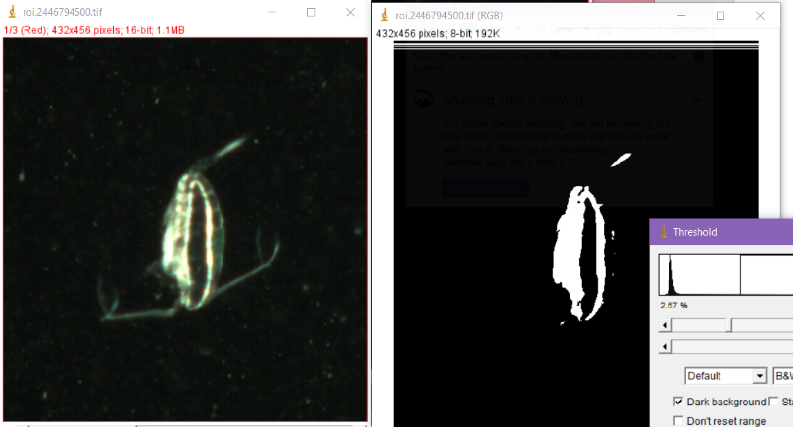

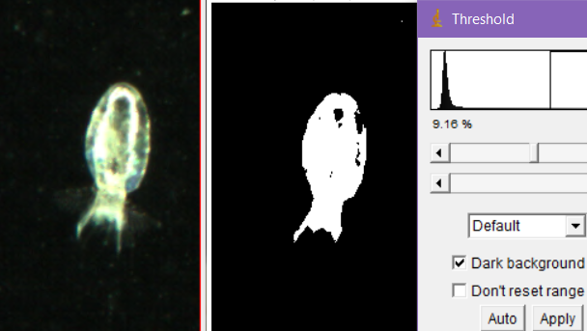

## Huang

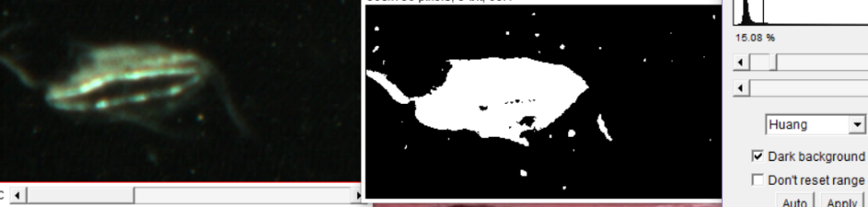

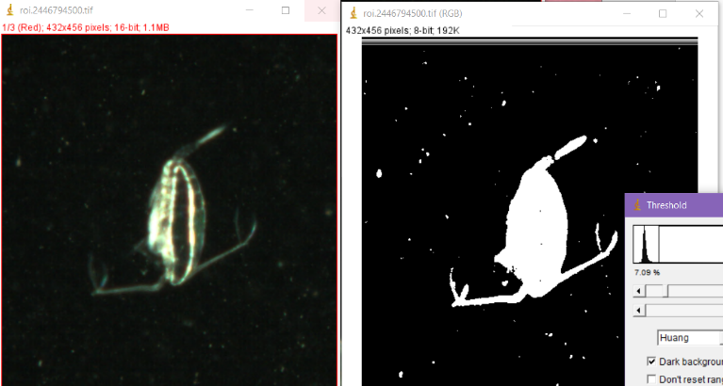

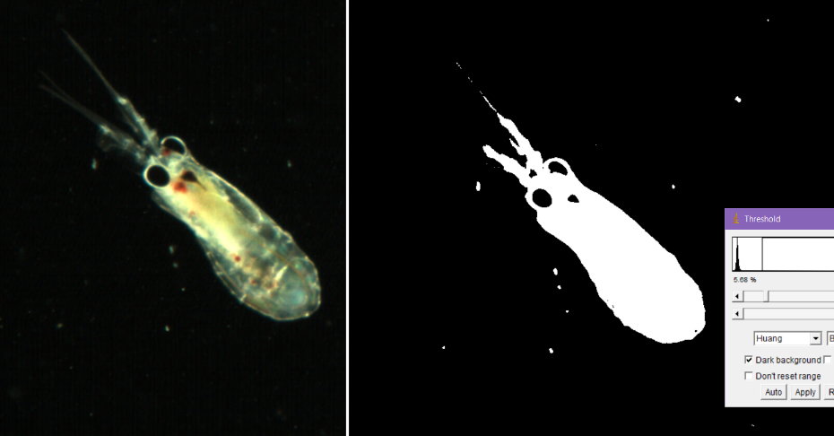

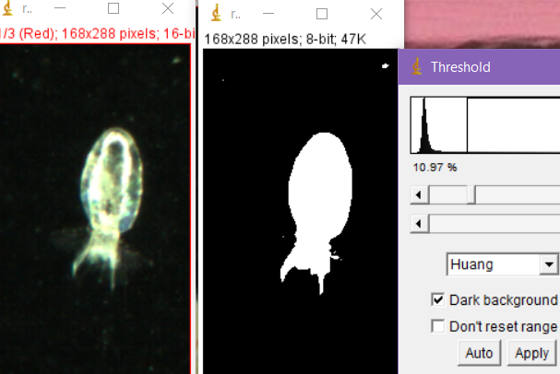

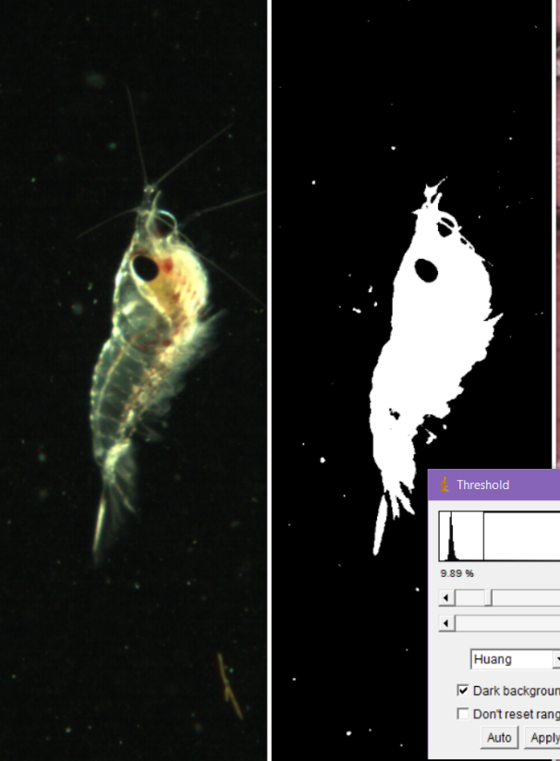

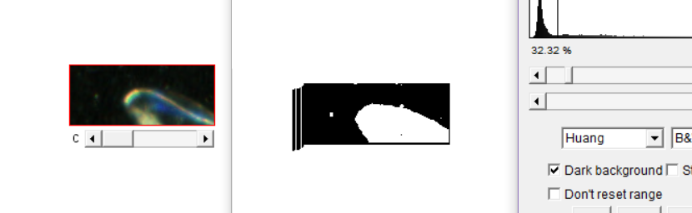

## Li

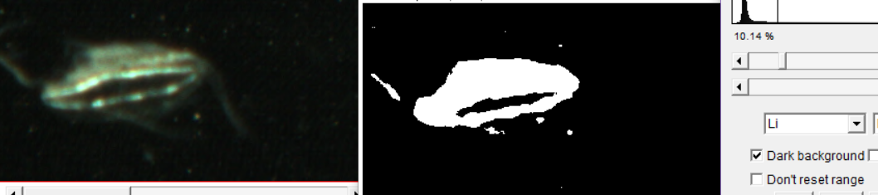

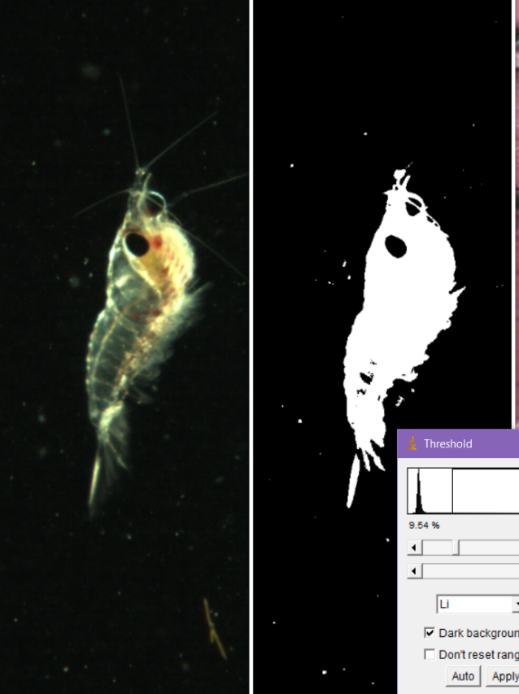

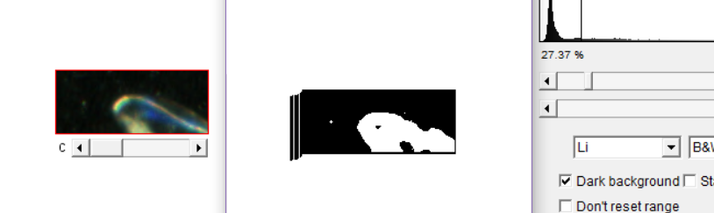

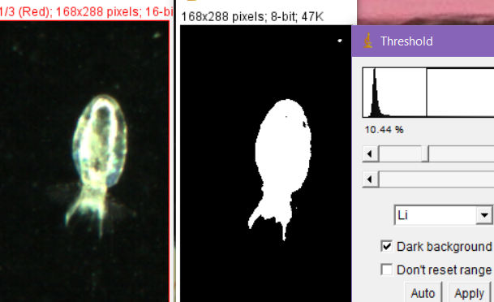

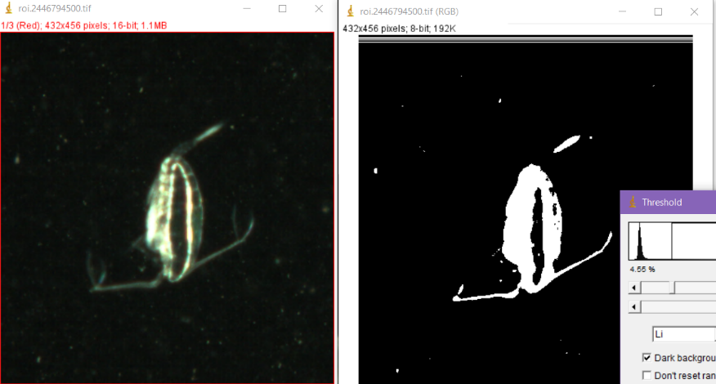

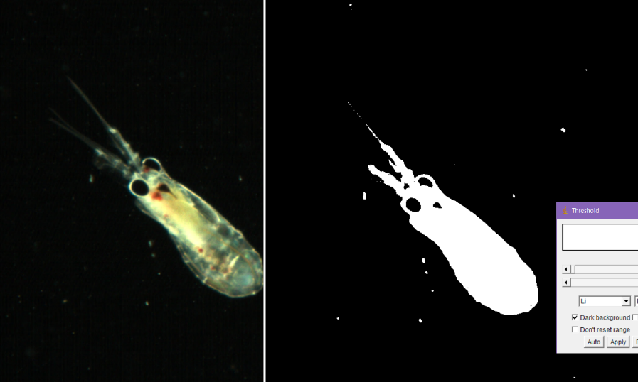

## MaxEntropy

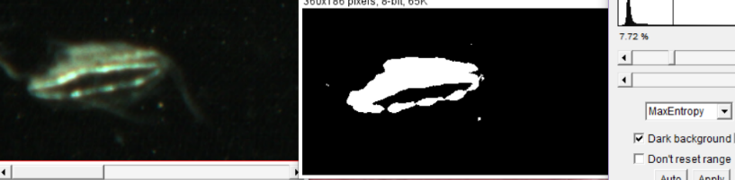

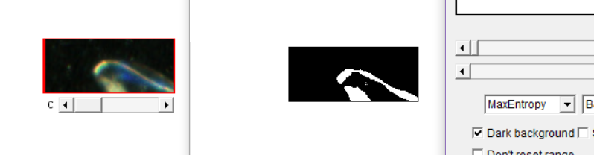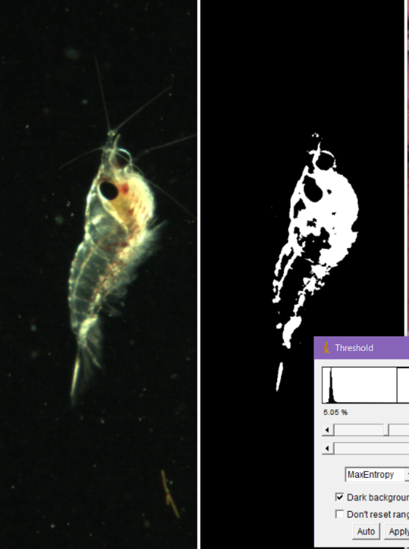

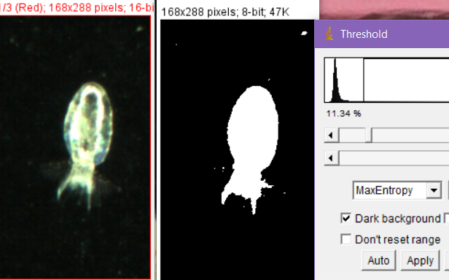

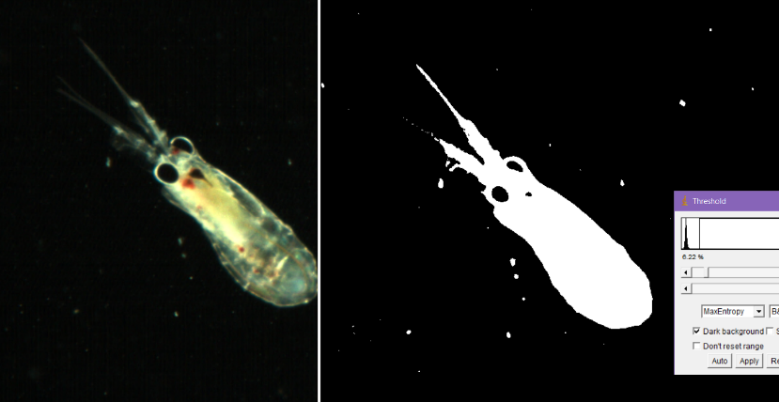

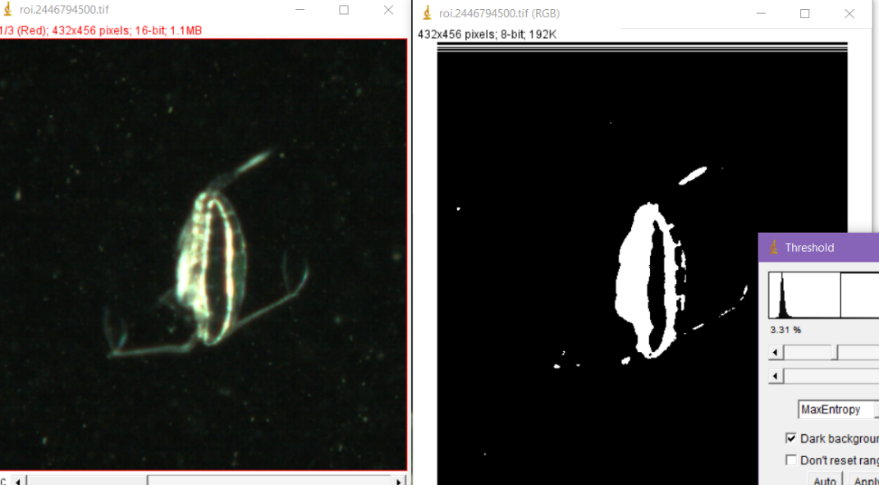

## RenyiEntorpy

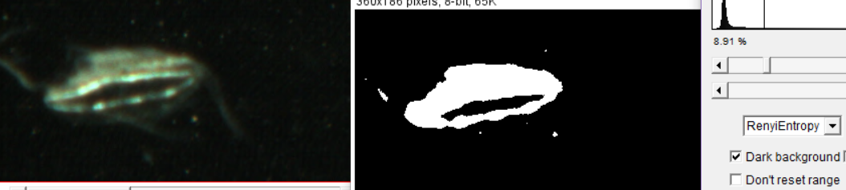

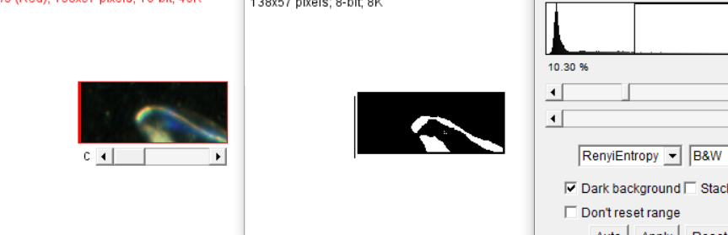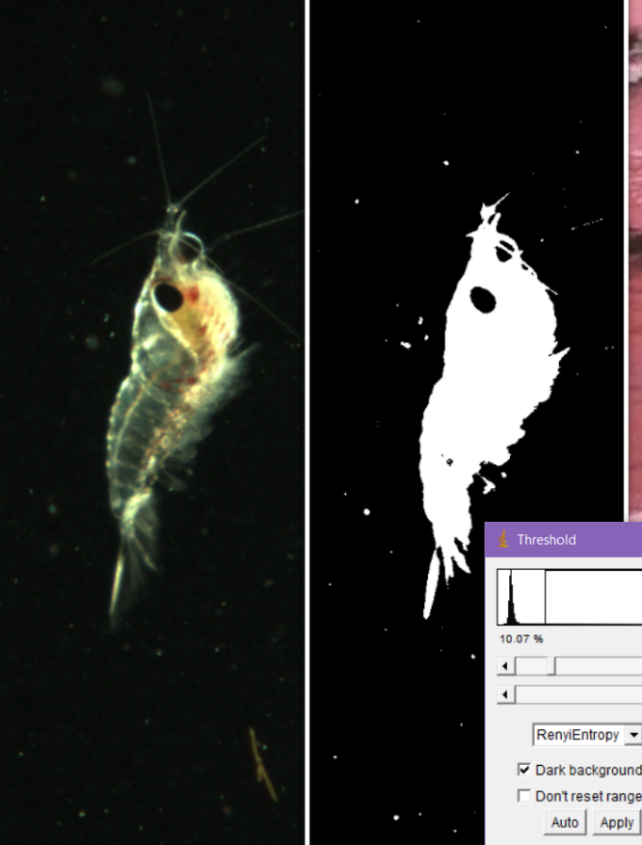

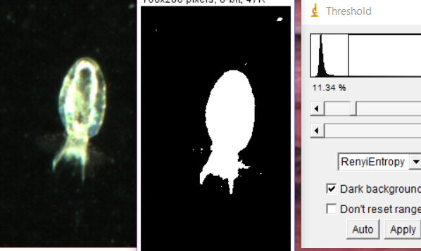

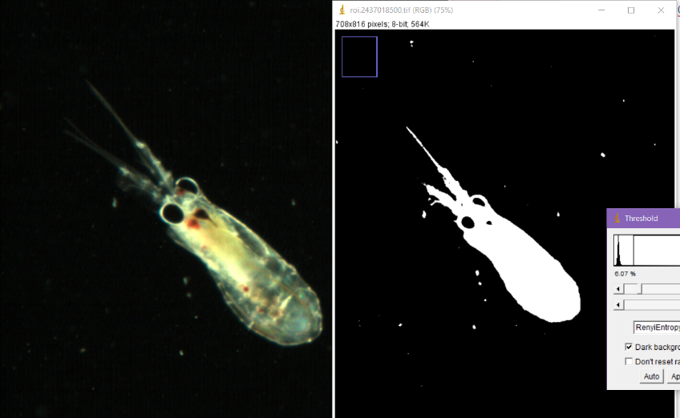

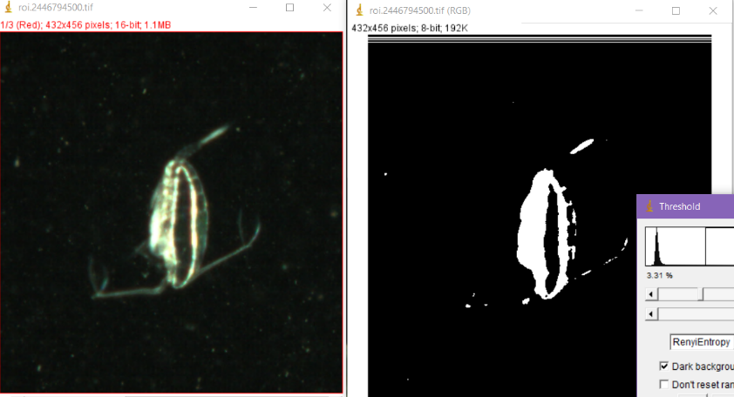

## Triangle

